# Introduction

## The design of an IoT Traffic Monitoring System involves the implementation of a comprehensive solution for monitoring and managing traffic conditions using Internet of Things (IoT) technology. By leveraging IoT devices, data analytics, and connectivity solutions, this system aims to provide real-time traffic information to commuters, optimize traffic flow, and alleviate congestion.

## 

To put the design of the IoT Traffic Monitoring System into transformation, the following steps can be taken:

## Document the Design:

Create a detailed document outlining the design of the IoT Traffic Monitoring System. This document should include the objectives, components, and benefits of the project, as well as the specific steps involved in its implementation.

1. Review and Refine the Design: Conduct a thorough review of the design document to ensure that all aspects of the system have been considered and that it aligns with the project objectives. Make any necessary refinements or adjustments to the design based on feedback and further analysis.
2. Identify Required Resources: Determine the resources needed to implement the design, including hardware, software, and personnel. This may involve procuring IoT devices, selecting appropriate data analytics tools, and identifying team members or external partners with the necessary skills and expertise.

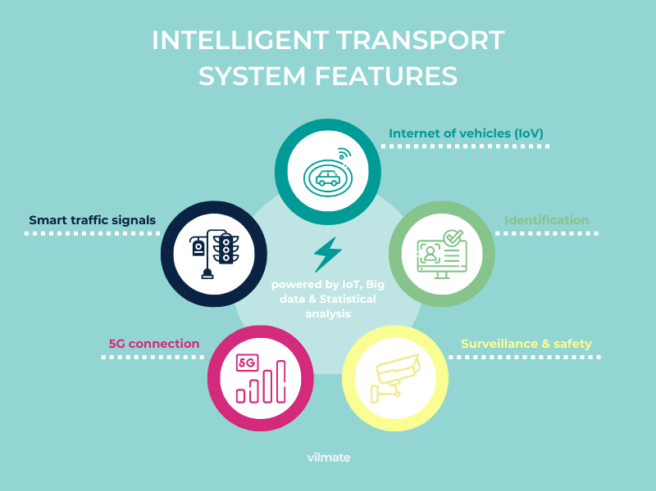

1. Develop a Project Plan: Create a comprehensive project plan that outlines the timeline, milestones, and tasks required to implement the design. This plan should include specific deliverables and deadlines for each phase of the project, as well as a clear allocation of responsibilities.
2. Implement the IoT Infrastructure: Begin by setting up the IoT infrastructure for traffic monitoring. This involves deploying IoT devices, such as sensors and cameras, at strategic locations to collect real-time traffic data. Ensure that the devices are properly installed and configured for data collection.

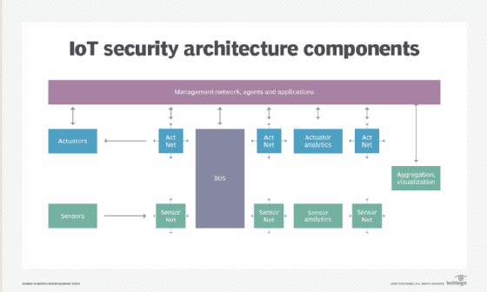

1. Establish Data Connectivity: Set up connectivity solutions to transmit the collected data from the IoT devices to a central server for analysis. This may involve establishing wireless or wired connections, configuring data protocols, and ensuring data security and privacy.
2. Develop the Traffic Information Platform: Design and develop a user-friendly platform or mobile app that provides commuters with access to real-time traffic information. The platform should display traffic conditions, suggest alternative routes, and provide estimated travel times based on the collected data. Consider incorporating additional features like notifications and alerts to enhance the user experience.
3. Integrate IoT Technology and Python: Integrate the IoT devices with Python-based data analytics tools to process and analyze the collected traffic data. Utilize Python libraries and frameworks, such as Pandas and NumPy, for data manipulation and analysis. Explore the use of machine learning algorithms to predict traffic patterns and congestion.
4. Test and Validate the System: Conduct thorough testing and validation of the IoT Traffic Monitoring System to ensure its functionality, accuracy, and reliability. Test the system under various traffic scenarios and conditions to verify its performance. Make any necessary adjustments or refinements based on the test results.
5. Document and Share the Implementation: Create a comprehensive document that outlines the implementation process, including the steps taken, challenges faced, and solutions implemented. Include relevant technical details, diagrams, and screenshots to provide a clear understanding of the system. Share this document with stakeholders and assessors for evaluation and feedback.

By following these steps, the design of the IoT Traffic Monitoring System can be effectively transformed into a functional and innovative solution for traffic monitoring and congestion alleviation.